**Ecommerce Applications Development**

Diploma in Information Technology

AY 2024/25 Semester 2

**Team cum Individual Assignment**

(40% of Overall Assessment)

Duration: Week 15 - 17

**Deadline for Submission:**

**9th February 2025 (Sunday), 2359 hrs**

|  |  |  |
| --- | --- | --- |
| **Class group** | : | P01 |
| **Tutor** | : | Mr Tan Choon Peng |
| **Team ID** | : | Team 04 |
| **Date of submission** | : |  |
| **Late** | : | YES / NO |

**Please fill in your Student Number and Name as appeared on your student card:**

|  |  |  |  |  |  |
| --- | --- | --- | --- | --- | --- |
| **Functions** | **Student No.** | **Student**  **Name** | **Team Grade** | **Individual Grade** | **Overall Grade** |
| **Membership**  **Registration** | S10221021 | Eddie Lau Shu Hui |  |  |  |
| **Product**  **Catalog** |  |  |  |  |  |
| **Shopping**  **Cart** | S10242033 | Teow Jun Wei |  |  |  |
| **Checkout** | S10222577 | Dani Tan |  |  |  |

**Penalty for late submission:**

10% of the marks will be deducted every day after the deadline.

No submission will be accepted after 16th February 2025, 2359 hrs.

# 1. Homepage (Team Component)

**Introduction: Default Homepage**

**Links: signin.php -> login.php**



**Site Name: BabyBoo**

In recent times, online shopping has become the norm especially with the advancement of technology. Hence, BabyBoo, is an online store for parents to purchase their needs for raising their children. As we know baby products like walkers and strollers can also be challenging to transport home if parents do not own a vehicle. Hence, with our website we aim to make it a reliable one stop shop for all parents to get all their needs in one go without having to worry about transporting large and clunky items back. The site is developed to have a shopping cart and allows users to make payments online and have their items delivered upon purchase.

The overall design ensures a seamless shopping experience with its clean structure and well-defined sections. The use of soft colours, clear fonts, and properly spaced elements makes navigation effortless. Whether users are looking to browse products, manage their shopping cart, or check their profile, the homepage serves as a central hub for all their shopping needs.

**Login Page**

**Links: login.php -> index.php**

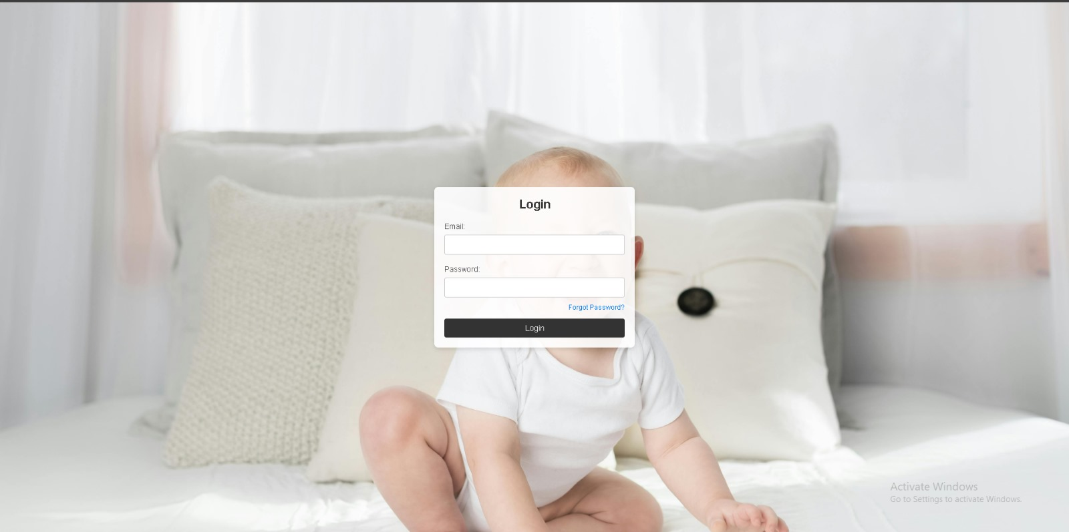

**Description:**

This is the login page for BabyBoo. After members have successfully registered for their new account, they will be led to the login page to proceed on with their shopping. However, if users were to forget their password, we have implemented the Forgot Password feature which will help retrieve their password from our database after simply answering their security question.

**Homepage after login**

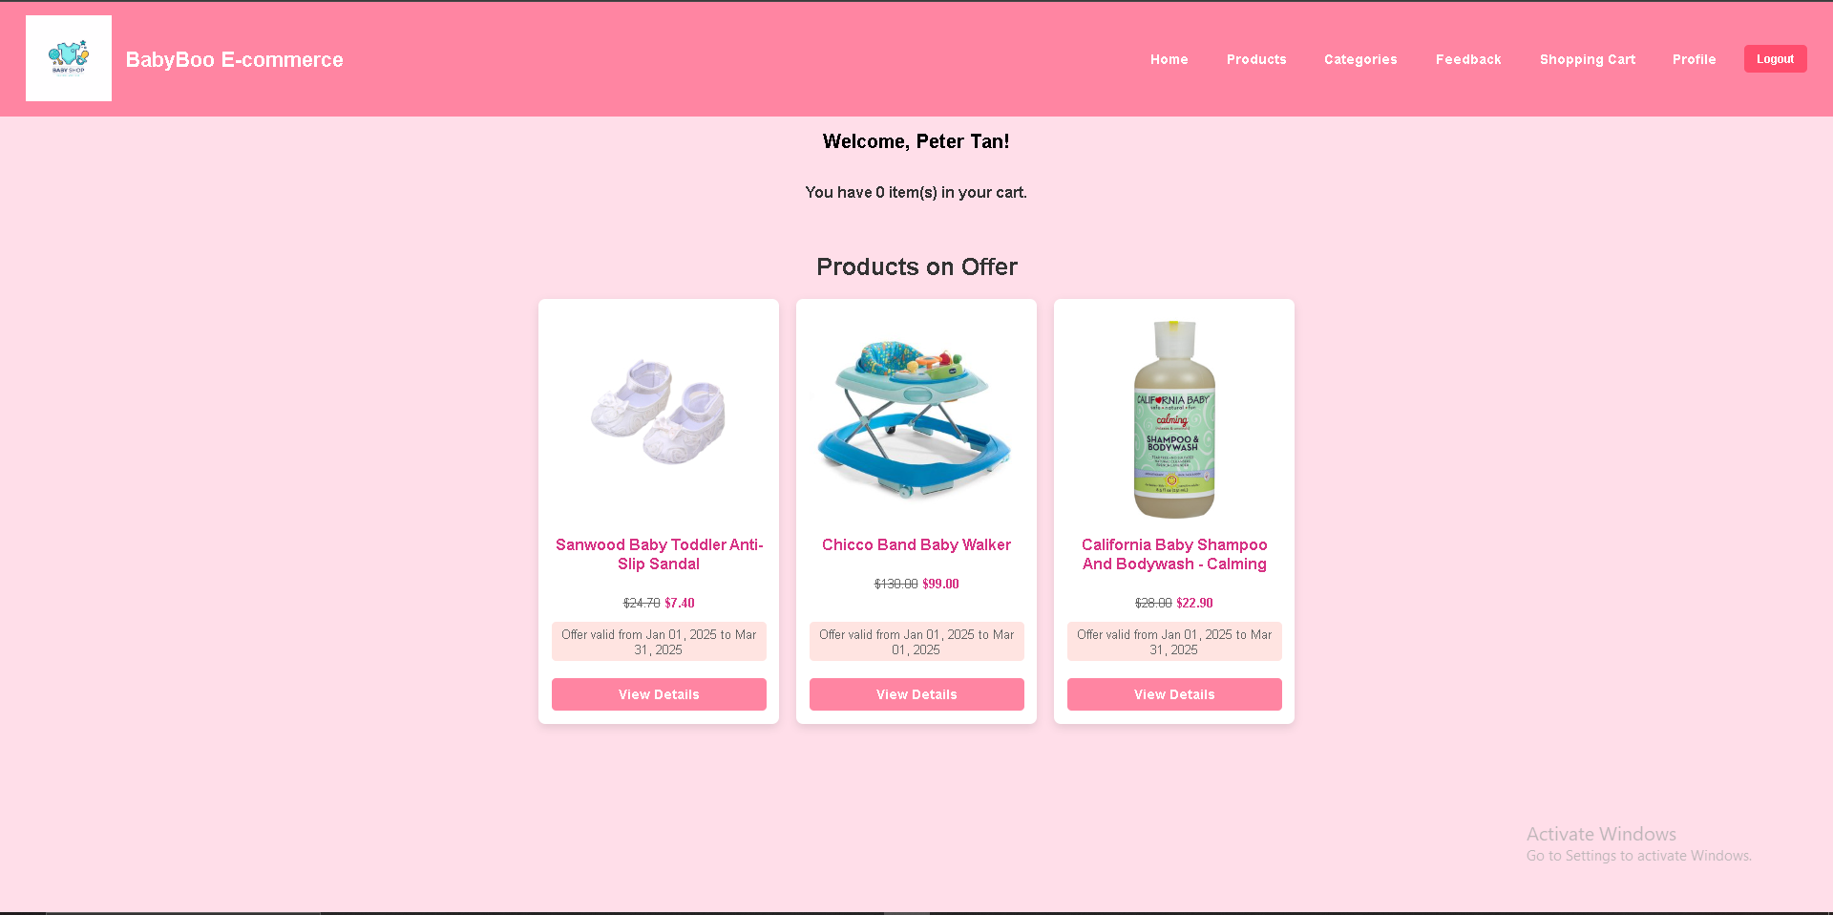

**Description:**

The BabyBoo E-commerce Homepage is a visually appealing and user-friendly landing page designed for an online baby product store. With a soft pink colour scheme, it creates a warm and inviting shopping experience for users. At the top, the page features a navigation bar that includes links to essential sections such as Home, Products, Categories, Feedback, Shopping Cart, and Profile, along with a convenient Logout button for users who are signed in.

Below the welcome message, users can see a summary of their shopping cart, displaying the total number of items they currently have. This feature enhances the user experience by providing quick access to cart details without navigating away from the homepage.

The main section of the page highlights featured products on offer, displaying a selection of baby essentials with discounted prices. Each product is neatly arranged in a card-style layout, showcasing an image, the original price (strikethrough), the discounted price in bold pink text, and the validity period of the offer. Additionally, each product card includes a "View Details" button, allowing users to explore more information about the item before making a purchase.

**Login Page Error**

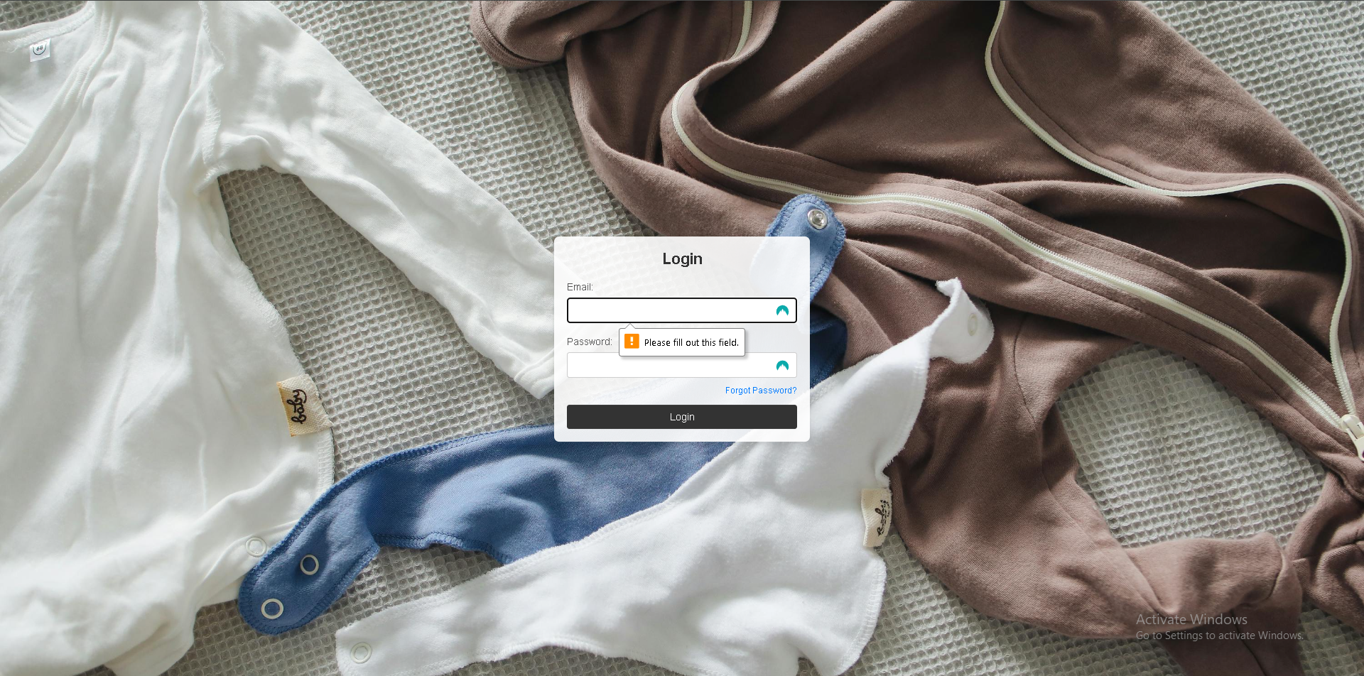

**Description:**

The screenshot above shows an error in the login page. When member did not fill in the required fields, a message pops up stating “Please fill out the field”. This is to show member that the required field is missing. Members must fulfil the required criteria to login.

# 2. Member Registration (Individual Component)

Done by: Eddie Lau Shu Hui

Links: signin.php -> signup.php

**signup.php**

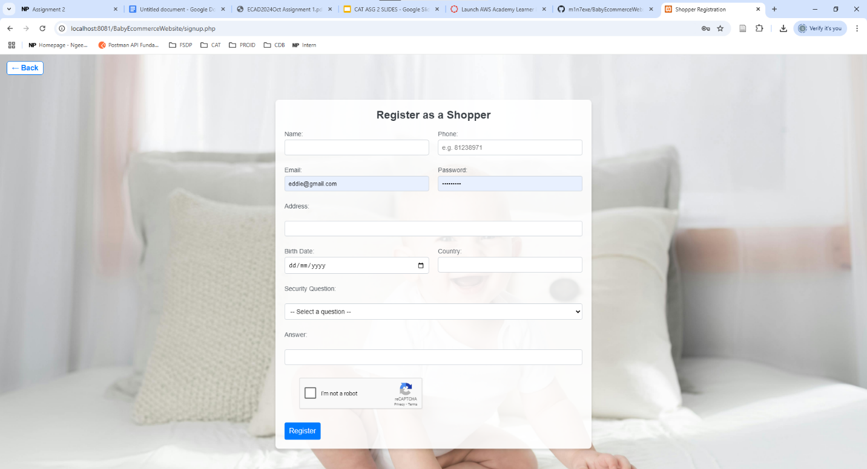

**Description:**

This is the Membership registration page for users who are interested in purchasing baby products from our website BabyBoo. Users are required to enter their personal details such as Name, Phone Number, Email, Password, Address, Birth Date, and Country. As for Security and as a way for password recovery we have a security question which users can choose between 4 questions and answer them accordingly. In addition, I have implemented an additional layer of security for security against possible spams or bot attacks using the google reCAPTCHA API.

After the user clicks on the “Register” button, if there is nothing wrong and all inputs are filled in, it will create a new row of data in our database to store the user’s details. However, there are valdiation checks in place for email addresses and phone numbers to ensure that there isn’t an existing row with the same email or phone number. Furthermore, there is an extra validation for Phone Numbers to ensure they begin with the numbers ‘6’, ‘8’ or ‘9’ as we are based in Singapore. If any of these validations fail, the form will reset and appear with a pop out telling them their error and prompting the user to re-submit their form with valid inputs. Same goes for the reCAPTCHA.

**Update Profile:**

Links: index.php -> profile.php

profile.php:

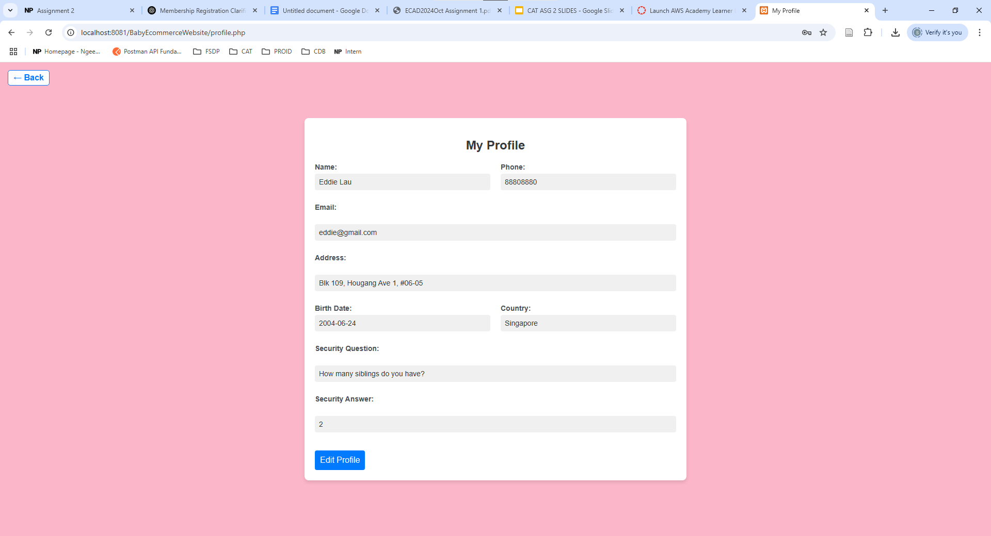

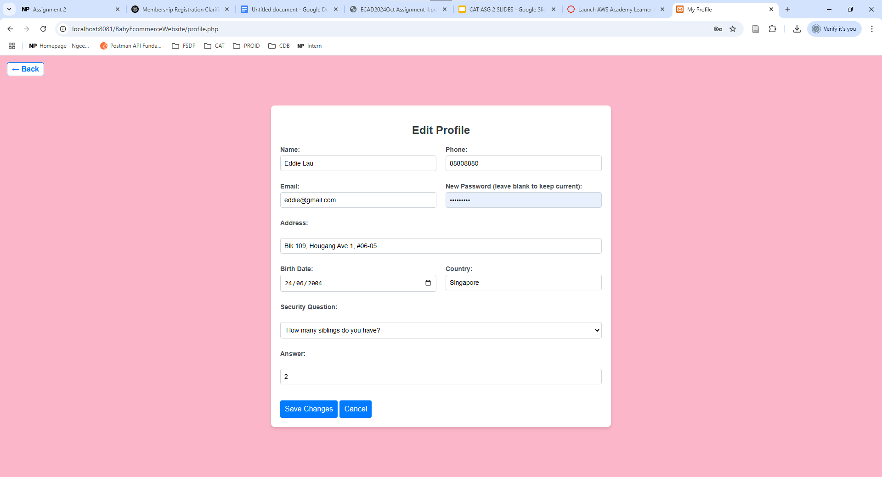

**Description:**

Before users can access this page, they would have to be logged in so that we can store their session variable. Members can see their account details and if they wish to change their details, they can click on the “Edit Profile” button. Thus, they can change their information as they wish, however if they would like to change other information and not their password, they can just leave the field blank, and it would just change the information they have updated. In addition, if they decided against changing their details, they can just click on the “Cancel” button. Finally, after pressing “Save Changes”, their updated details will be updated and stored in the database.

**Advanced Feature 1: Forget Password**

Links: signin.php -> login.php -> forgot_password.php

forgot_password.php:

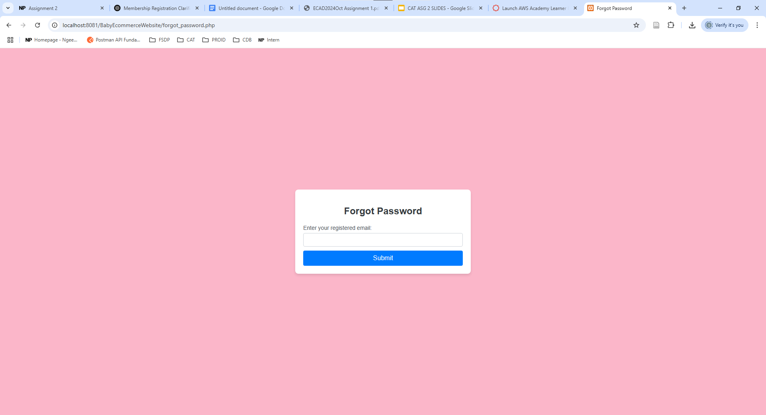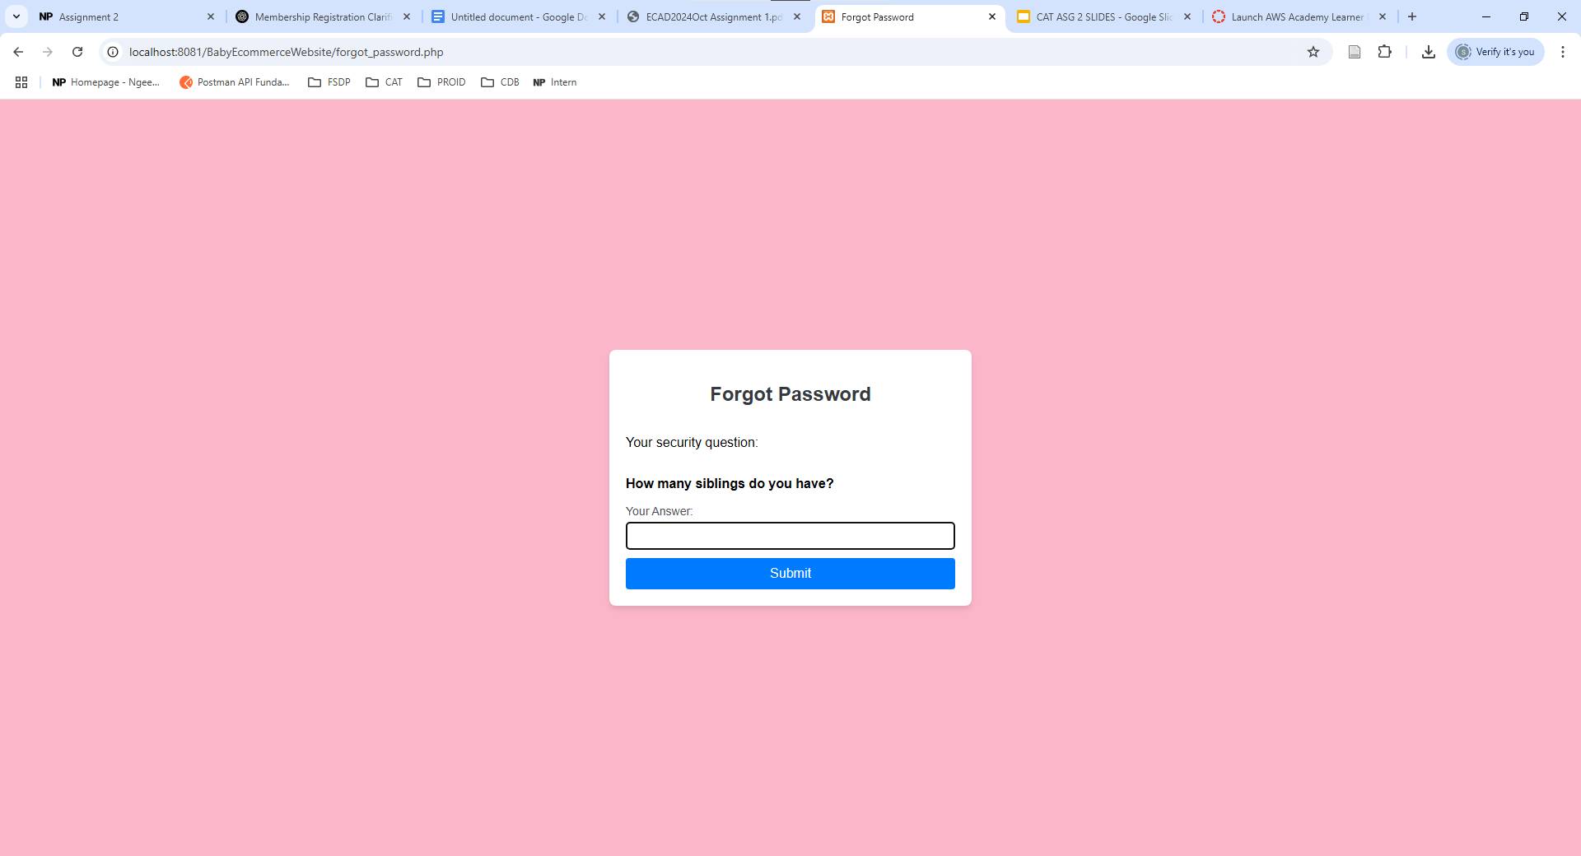

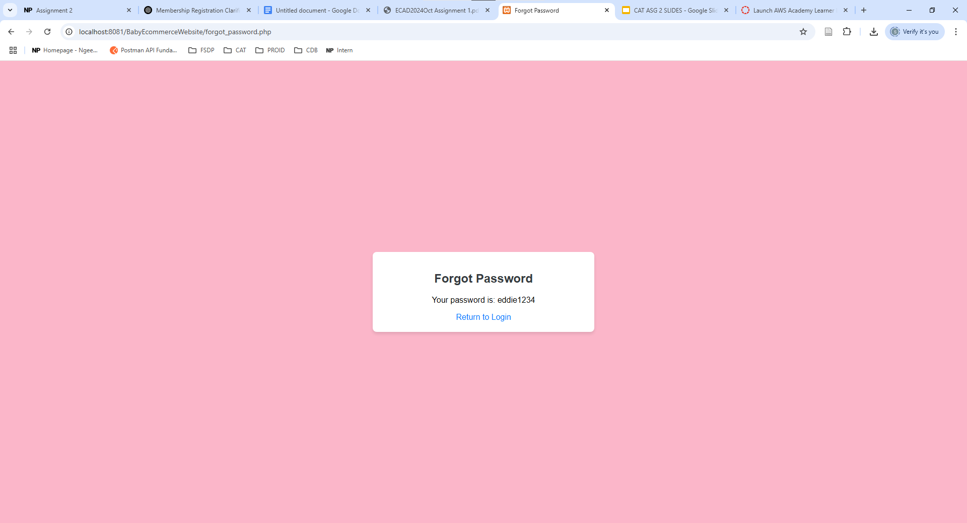

**Description:**

This is the page where members will come if they have forgotten their password. They will first be on the Login page and click on the “Forgot Password?” button which will bring them to this page. In order for them to retrieve their password, they will have to enter their email address that they had used to register for their account. The system will then use their email retrieve their security question from the database and display it to the user. The user will have to answer the question correctly, which will then display their password and click on the button that will redirect them back to the Login page. From there, the user can try their login details again and be directed to our website.

**Advanced Feature 2: Ranking and Feedback for Website**

Links: index.php -> feedback.php

feedback.php:

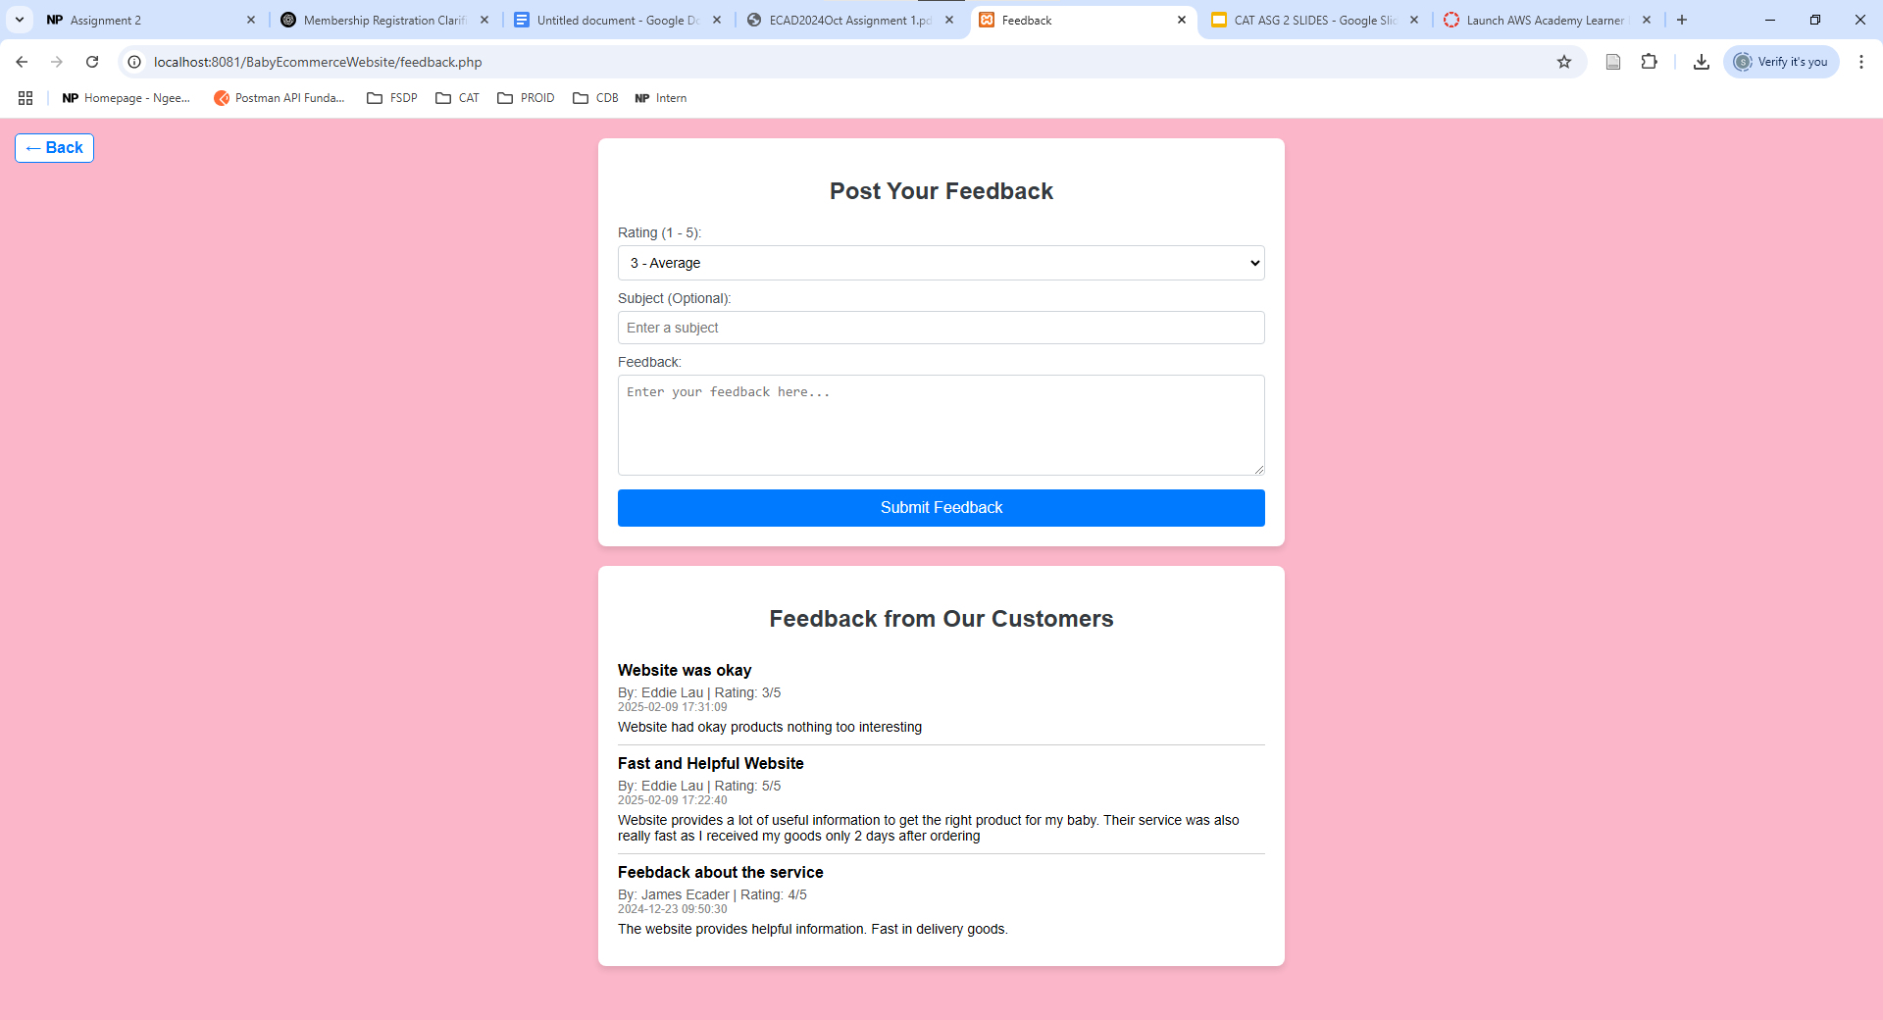

**Description:**

If users would like to leave a ranking and feedback on products or the service they have received, they can access the Feedback page which includes the Feedback form and the Feedback given from Customers retrieved from the Database. Firstly, members can choose a rating from 1 to 5 depending on how satisfied they were with their experiences and can input a title and write their detailed feedback on their experience. After clicking on “Submit Feedback” the information will be stored in our Database which will also log the Date and Time at which the Feedback was created.

Finally, all feedback submitted will be retrieved from the database and shown in the Feedback page as well. Feedback shown will include information like member’s Name, Rating, Feedback Title, Feedback Details and the Date and Time it was created.

# 3. Product Catalog (Individual Component)

Done by:

# 4. Shopping Cart (Individual Component)

**Done by: Teow Jun Wei (S10242033)**

**Basic Requirements:**

**Links: index.php -> cart.php**

**cart.php**

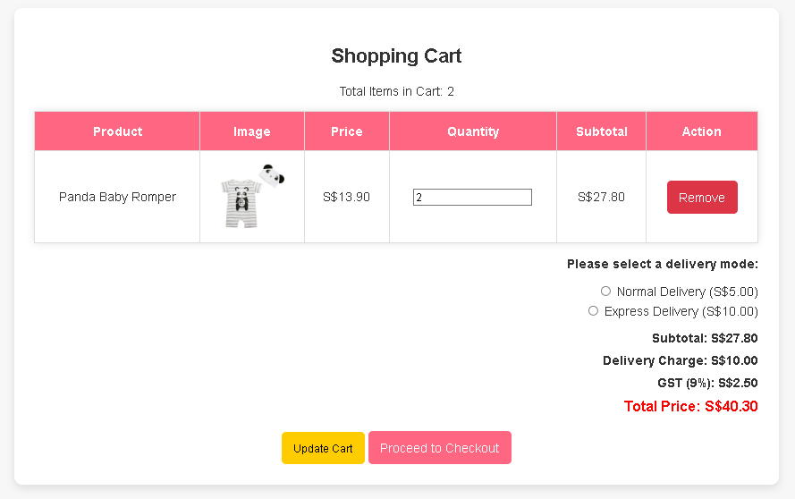

**Description**

The Shopping Cart page provides users with an overview of the items they have selected for purchase. It displays essential details such as the product name, image, price, quantity, subtotal, and an option to remove items from the cart. Users can adjust the quantity of each product and click the "Update Cart" button to reflect any changes. Additionally, the page includes a delivery mode selection, allowing users to choose between Normal Delivery (S$5.00) and Express Delivery (S$10.00).

Below the cart items, a summary section calculates the subtotal, delivery charge, and GST (9%), ultimately displaying the Total Price in bold red text for clear visibility. Once satisfied with their cart, users can proceed to checkout by clicking the "Proceed to Checkout" button, where they will complete their payment and shipping details. The cart page ensures a smooth shopping experience by providing real-time updates on total costs and available options.

**Empty Shopping Cart**

**Description**

The Shopping Cart page informs users that their cart is currently empty. It displays a message indicating that there are 0 items in the cart, encouraging users to continue browsing and adding products to their cart. To facilitate this, a "Go to Shopping Now" button is prominently placed, allowing users to quickly navigate back to the product listings and explore available items. The clean and minimal design ensures a smooth user experience while subtly guiding shoppers toward making their first selection.

**Validation for Quantity Input**

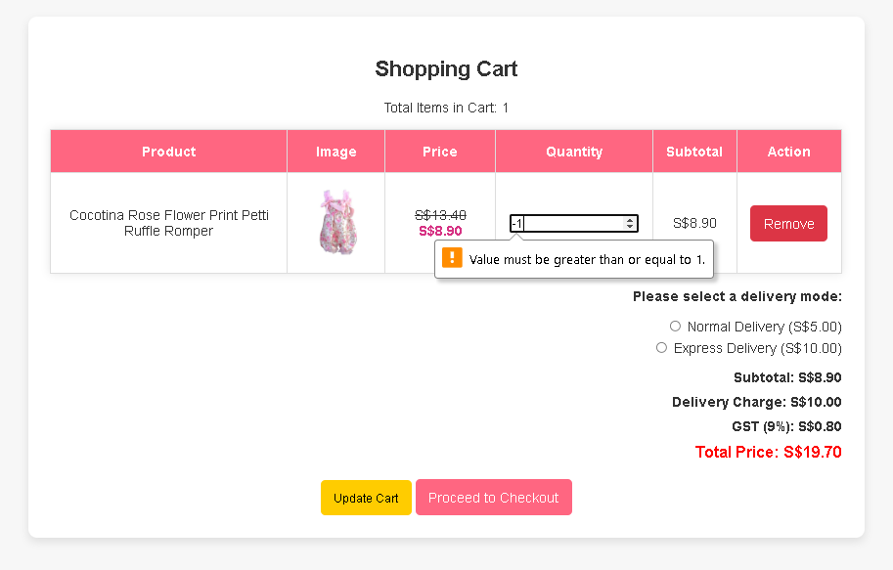

**Description**

The quantity validation message ensures that users input a valid quantity when updating their shopping cart. If a user attempts to enter a number less than 1, an error message appears stating: "Value must be greater than or equal to 1." This prevents negative or zero values, ensuring that customers only order valid quantities of a product. The validation mechanism enhances the user experience by guiding them towards correct input values, reducing checkout errors, and maintaining inventory accuracy.

**Advanced Feature 1: Delivery Charge Waiver**

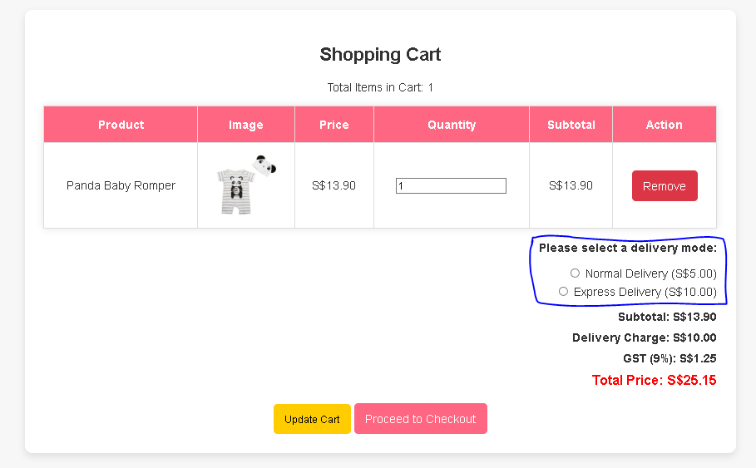

**Description**

The delivery method selection allows customers to choose between Normal Delivery (S$5.00) and Express Delivery (S$10.00) based on their preference. However, to provide a better shopping experience, the system waives the delivery charge if the subtotal exceeds S$200. This encourages bulk purchases while ensuring customers receive their orders promptly. The delivery cost is dynamically updated based on the selected option and the total order amount, helping customers make an informed decision before proceeding to checkout.

**Advanced Feature 2: Total Item Count Calculation**

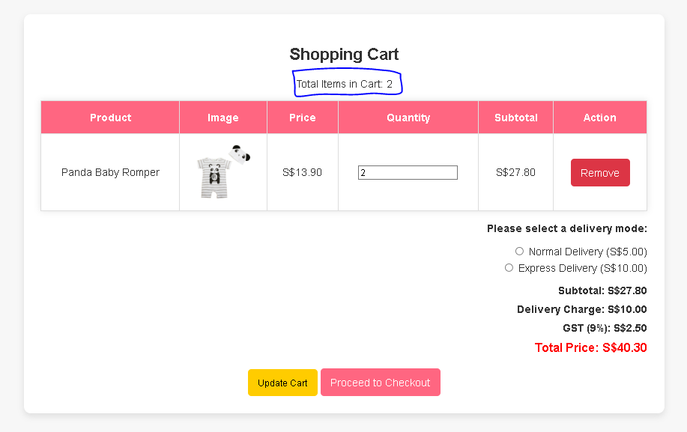

**Description**

The shopping cart now displays the total quantity of items that the user intends to checkout. This feature provides a more accurate representation of the total number of products rather than just the number of different product types. Instead of simply counting unique products, the system sums up the quantity of each product in the cart.

For example, if a user adds 2 pieces of Product A and 3 pieces of Product B, the total items in cart will display 5, reflecting the actual number of items being purchased. This advanced feature enhances clarity for users, ensuring they have a complete view of their order before proceeding to checkout.

**Additional Feature: Real-Time Cart Display on index.php**

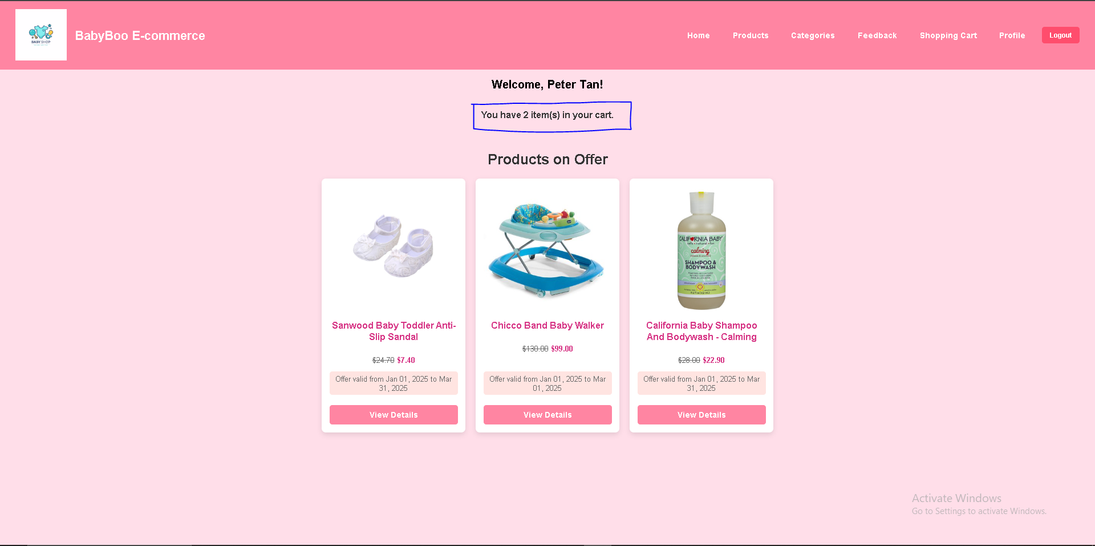

**Description**

The index.php page now includes a real-time display of the total number of items in the shopping cart. This feature ensures that users are always aware of how many products they have added while browsing the store. The total count is dynamically updated based on the quantity of each item in the cart, rather than just the number of unique products.

For instance, if a user adds 2 units of Product A and 3 units of Product B, the system will display "You have 5 item(s) in your cart." This provides a clear and accurate view of the total purchase quantity, helping users keep track of their shopping progress before proceeding to checkout.

# 5. Checkout (Individual Component)Done by: Dani Tan

Links: Index.php → cart.php

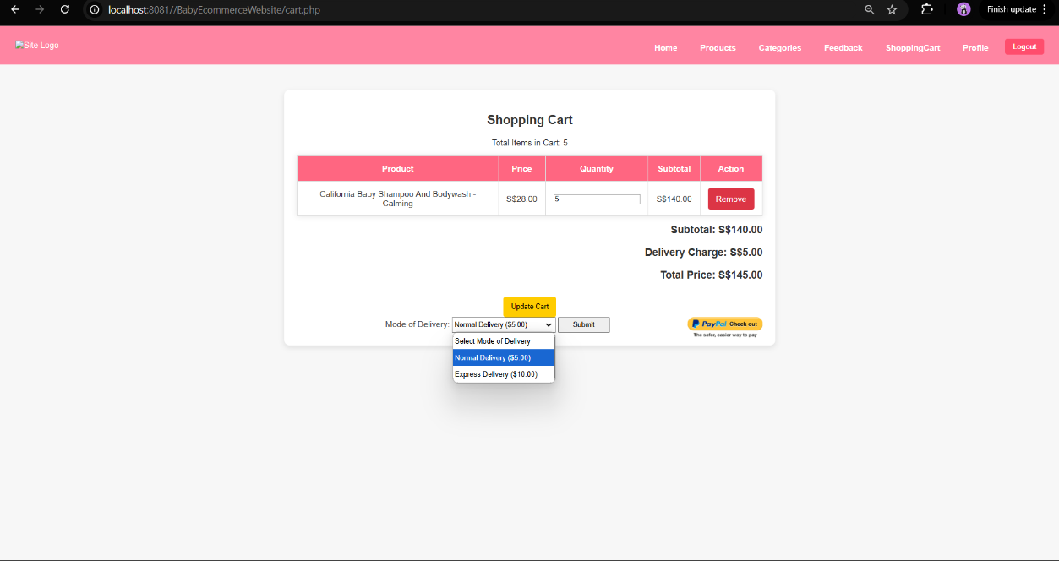

Links: Index.php → cart.php  → myPayPal.php

Description:

Delivery is available exclusively within Singapore, offering two delivery options. The delivery charge is determined by the selected mode: **Normal Delivery**, costing $5 per trip, delivers within 2 working days of placing an order, while **Express Delivery**, costing $10 per trip, ensures delivery within 24 hours of placing an order.

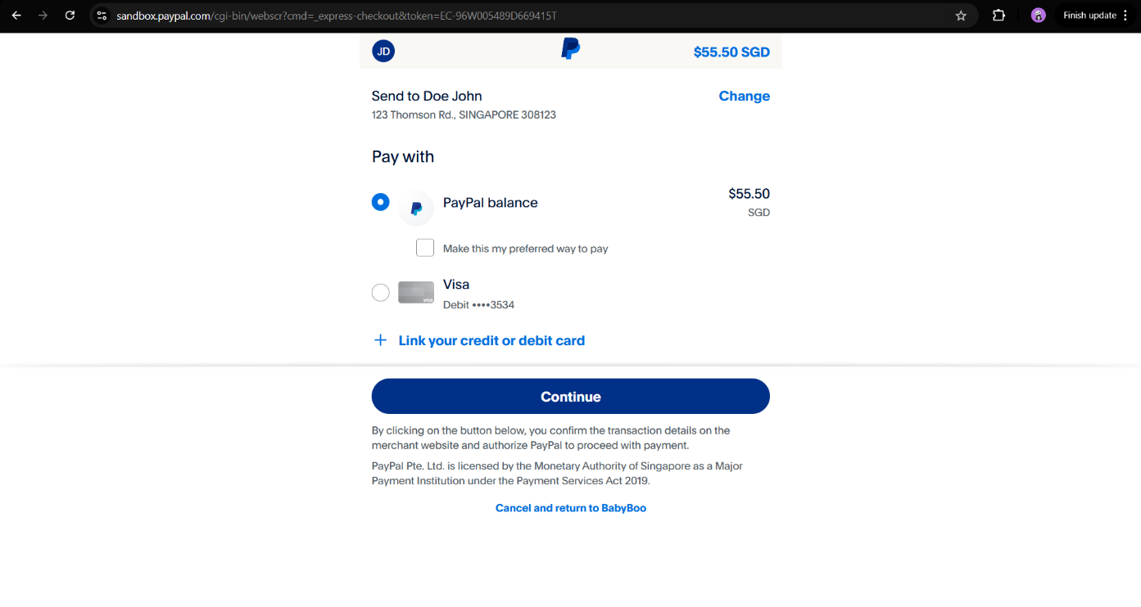

Description:

At checkout, customers are required to make a payment via PayPal. During the PayPal payment process, the customer's details, such as name and address, are displayed. Additionally, the total amount for the items purchased is shown. Customers can also click on cancel to continue shopping.

Description:

Once the payment is successfully processed, the system will redirect the user back to a confirmation page on the website.

The confirmation page serves as a receipt for the shopper, displaying critical details of the transaction, including the unique order ID. This order ID acts as a reference for the shopper, as well as informing the shopper that the transaction was successful.